Story 07 Update a Book

## Description

As a user

I want to update a book of the collection

So that the updated book will be stored in the database

## Wireframe (in Thunder Client)

Happy case:

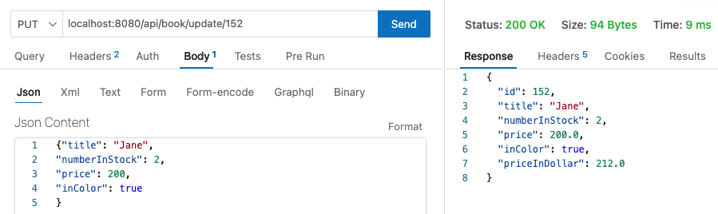

Unhappy case – Title is not unique:

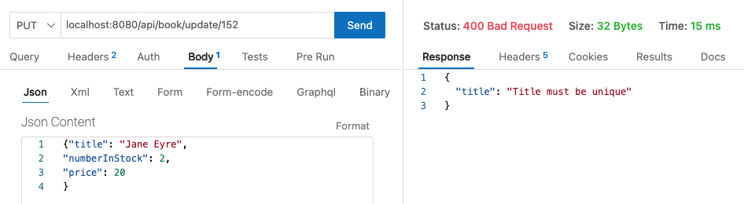

Unhappy case – Field errors:

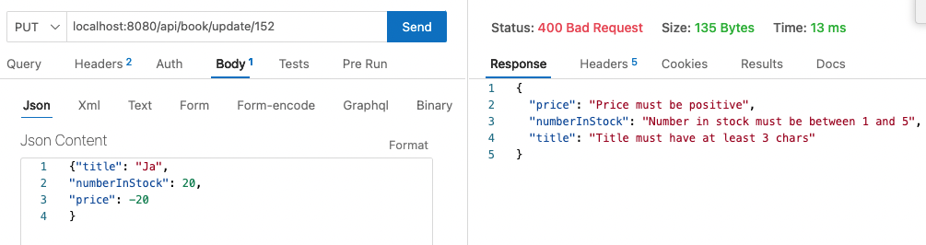

Unhappy case – Invalid id:

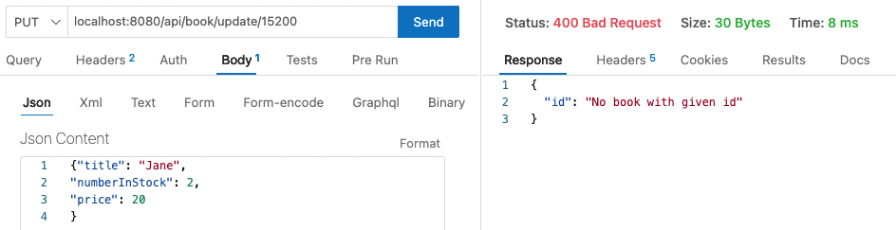

## API

|  |  |
| --- | --- |
| Request | PUT |
| URL | http://localhost:8080/api/book/update/{id} |
| Path Variable | Id (int) as path variable |
| Request Body | A Book object (JSON) – fields: title, numberInstock, price, inColor |
| Output: happy case | A Book object (JSON) – all fields |
| Output: unhappy case | Response 400 BAD REQUEST  JSON error messages with field(s)  •"id": "No book with given id"  •"price": "Price must be positive"  •"numberInStock": "Number in stock must be between 1 and 5"  •"title": "Title must have at least 3 chars"  •"title": "Title is required"  •"title": "Title must be unique" |
| Acceptance Criteria | The book with given id is updated with the values of the fields in the request body.  The new values are valid cfr validation of a new book (including uniqueness of title).  The id of the book is not changed.  Returns the updated book |